MIDTERM EXAMINATION
TIME ALLOWED: 90’
Subject: Linear Algebra.
No Book and Laptop allowed

- Let 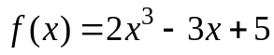 and 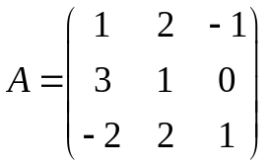. Compute 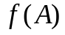.
- Calculate the determinant of the following matrix
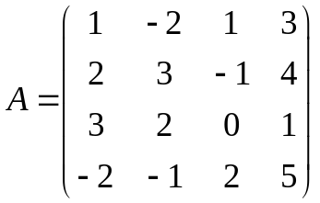
- Determine all real value(s) m, such that the matrix

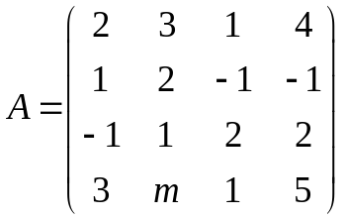 is invertible.

- Compute the inverse (if possible) of the matrix 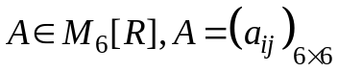,
where 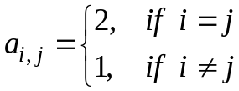.
- Let 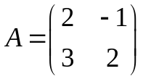. Compute 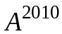, given 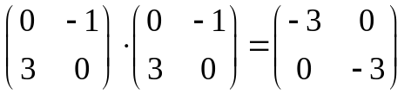.
- Solve the following system of linear equations

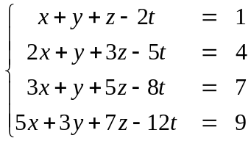
-----------------------  -----------------------

Chủ nhiệm Bộ Môn (Head of Math Department):

